Exercise-1

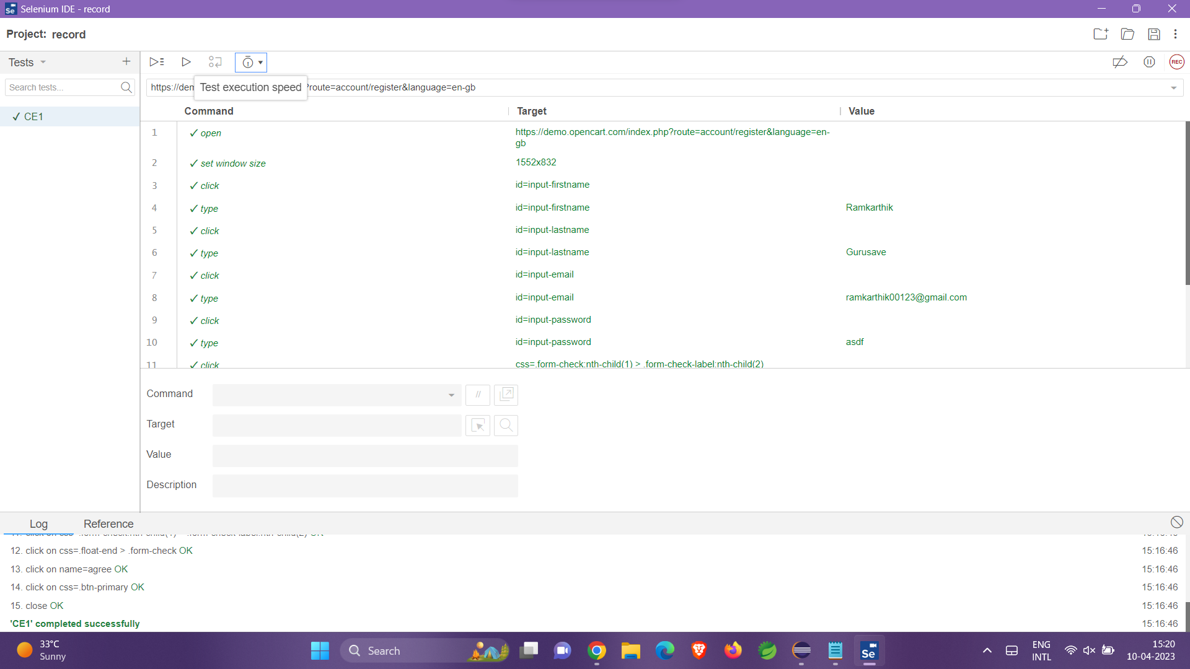

CE -2:

package com.testing.demo;

import org.openqa.selenium.By;

import org.openqa.selenium.WebDriver;

import org.openqa.selenium.WebElement;

import org.openqa.selenium.chrome.ChromeDriver;

import io.github.bonigarcia.wdm.WebDriverManager;

/**

* Hello world!

*

*/

public class App

{

public static void main( String[] args )

{

WebDriverManager.*chromedriver*().setup();

WebDriver driver=new ChromeDriver();

driver.get("https://demo.opencart.com/index.php?route=account/register&language=en-gb");

driver.manage().window().maximize();

WebElement fname= driver.findElement(By.*id*("input-firstname"));

fname.sendKeys("Ramkarthik");

WebElement lname=driver.findElement(By.*xpath*("//input[@id=\"input-lastname\"]"));

lname.sendKeys("C");

WebElement email=driver.findElement(By.*cssSelector*("input#input-email"));

email.sendKeys("abc2gmail.com");

driver.findElement(By.*id*("input-password")).sendKeys("pass@123");

driver.findElement(By.*xpath*("//input[@id=\"input-newsletter-yes\"]")).click();

driver.findElement(By.*xpath*("//input[@name=\"agree\"]")).click();

driver.findElement(By.*xpath*("//button[@class=\"btn btn-primary\"]")).click();

}

}

CE-3:

package com.testing.demo;

import org.openqa.selenium.By;

import org.openqa.selenium.JavascriptExecutor;

import org.openqa.selenium.WebDriver;

import org.openqa.selenium.chrome.ChromeDriver;

import io.github.bonigarcia.wdm.WebDriverManager;

public class CE3 {

public static void main(String[] args) throws InterruptedException {

WebDriverManager.*chromedriver*().setup();

WebDriver driver=new ChromeDriver();

driver.get("https://demo.opencart.com/index.php?route=checkout/voucher&language=en-gb");

driver.manage().window().maximize();

driver.findElement(By.*xpath*("//*[@id=\"input-to-name\"]")).sendKeys("Ramkarthik");

JavascriptExecutor js=(JavascriptExecutor) driver;

js.executeScript("window.scrollBy(0,500)", "");

driver.findElement(By.*xpath*("//*[@id=\"input-to-email\"]")).sendKeys("ram@qwerty");

driver.findElement(By.*xpath*("//*[@id=\"input-from-name\"]")).sendKeys("Ramkarthik");

driver.findElement(By.*xpath*("//*[@id=\"input-from-email\"]")).sendKeys("Ram@sdgfs");

driver.findElement(By.*xpath*("//*[@id=\"input-theme-7\"]")).click();

driver.findElement(By.*xpath*("//*[@id=\"input-message\"]")).sendKeys("Here is a gift for you love");

js.executeScript("window.scrollBy(0,500)", "");

Thread.*sleep*(5000);

driver.findElement(By.*xpath*("//*[@id=\"form-voucher\"]/div[8]/div/div/input")).click();

driver.findElement(By.*xpath*("//*[@id=\"form-voucher\"]/div[8]/div/button")).click();

CE-4:

package com.testing.demo;

import org.openqa.selenium.By;

import org.openqa.selenium.JavascriptExecutor;

import org.openqa.selenium.WebDriver;

import org.openqa.selenium.chrome.ChromeDriver;

import org.openqa.selenium.chrome.ChromeOptions;

import io.github.bonigarcia.wdm.WebDriverManager;

public class CE4 {

public static void main(String[] args) {

ChromeOptions co = new ChromeOptions();

co.addArguments("--remote-allow-origins=*");

WebDriverManager.*chromedriver*().setup();

WebDriver driver = new ChromeDriver(co);

driver.navigate().to("https://j2store.net/free/");

driver.manage().window().maximize();

JavascriptExecutor js = (JavascriptExecutor) driver;

js.executeScript("window.scrollBy(0,500)", "");

driver.findElement(By.*xpath*("//*[@id=\"Mod112\"]/div/div/ul/li[1]/h4/a")).click();

driver.navigate().back();

driver.navigate().forward();

driver.navigate().refresh();

driver.close();

}

}

CE – 5.1:

package com.testing.demo;

import org.openqa.selenium.WebDriver;

import org.openqa.selenium.chrome.ChromeDriver;

import io.github.bonigarcia.wdm.WebDriverManager;

public class ce5 {

public static void main(String[] args) throws InterruptedException {

WebDriverManager.*chromedriver*().setup();

WebDriver driver=new ChromeDriver();

driver.get("https://j2store.net/free/");

driver.manage().window().maximize();

String currentUrl=driver.getCurrentUrl();

String expectedUrl="https://j2store.net/free/";

if(currentUrl.equals(expectedUrl)) {

System.***out***.print("URL MATCHES");

}

else {

System.***out***.print("URL NOT MATCHED");

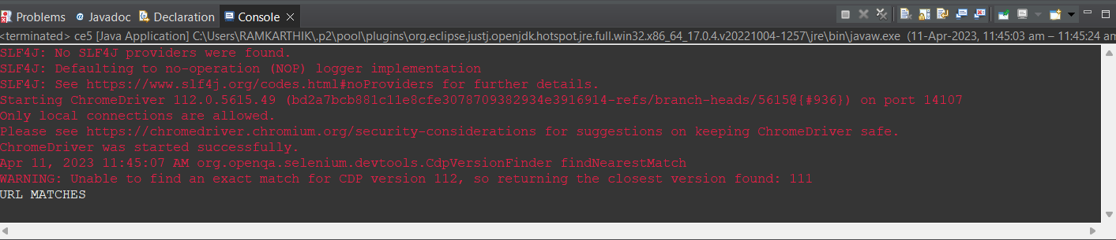

CE-5.2:

package com.testing.demo;

import java.util.List;

import org.openqa.selenium.By;

import org.openqa.selenium.JavascriptExecutor;

import org.openqa.selenium.WebDriver;

import org.openqa.selenium.WebElement;

import org.openqa.selenium.chrome.ChromeDriver;

import io.github.bonigarcia.wdm.WebDriverManager;

public class ce5_2 {

public static void main(String[] args) throws InterruptedException {

WebDriverManager.*chromedriver*().setup();

WebDriver driver=new ChromeDriver();

driver.get("https://j2store.net/free/");

driver.manage().window().maximize();

JavascriptExecutor js=(JavascriptExecutor) driver;

js.executeScript("window.scrollBy(0,500)", "");

driver.findElement(By.*linkText*("Clothing (5)")).click();

Thread.*sleep*(5000);

List<WebElement> l1=driver.findElements(By.*xpath*("//h2[@itemprop=\"name\"]"));

for(WebElement link:l1)

{

System.***out***.println(link.getText());

}

}

}







